ASEEV, Nikolai Nikolaiyevich (Николай Николаевич Асеев) (1889-1963)

Influential poet in the early Soviet Union. Born in Lgov, in the province of Kursk, died in Moscow. Studied in Moscow and Kharkov and began publishing poems in 1913 under the influence of both Russian Symbolism and Futurism. In 1916 married Kseniya Mikhailovna Sinyakova, who became a poetic muse, like her sister Zinaida (Boris Pasternak’s second wife). As member of the small Siberian literary group *Creation* (*Tvorchestvo*), wrote early hymns to the revolution. Aseev soon became the best-known follower of Mayakovsky, experimenting with avant-garde sound poetry and other formal innovations. In the early 1920s he published several speculative science-fiction stories. Along with many well-known Soviet writers, he contributed regularly to the influential avant-garde journals *LEF* (1923-25) and *New LEF* (1927-28), where his poetry expressed an enthusiasm for youth and the revolution. Aseev l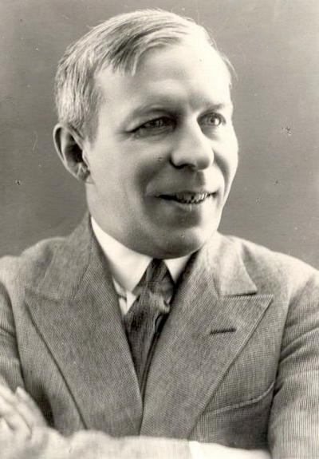ater merged his interest in older lyrical forms such as the ballad and folksong with an embrasure of mainstream socialist realism. His work in the 1940s responded to the Second World War with strong patriotic pathos, and his verse epic “Mayakovsky Begins” won the Stalin State Prize in 1941. He spent most of his adult life in Moscow, where he continued writing until his death.

References & Further Reading:

- Akhapkin, Denis (2004). "Nikolai Nikolaevich Aseev.” In  Kalb, Judith E. (ed. and introd.) Ogden, J. Alexander (ed. and introd.) Vishnevetsky, I. G. (collaborator) , *Dictionary of Literary Biography: Russian Writers of the Silver Age, 1890-1925*,  Detroit, MI: Thomson Gale, pp. 48-53. Brief but thorough literary biography, with a complete bibliography and references to Russian sources. An excellent starting point.

- Markov, Vladimir (1968). *Russian Futurism: A History*. Berkeley: University of California Press. Definitive work on the topic, with references to and discussions of the early Aseev throughout.

- Ozerov, L. (1966-1967)“Aseev Makes His Appearance,” *Russian Studies in Literature,* Volume 3, Number 1, January, pp.80-89. The only English-language essay devoted entirely to Aseev.

- Stephan, Halina (1980). “*Lef* and the Development of Early Soviet Prose,” *SEEJ*, Vol. 24, No. 4.

- ____ (1981). *‘LEF’ and the Left Front of the Arts*. Munich: Verlag Otto Sagner.

Article and book both occasionally discuss Aseev in the context of the journal *LEF* (*Left Front of the Arts*).

Major Works:

Collections:

Sobrannie sochenennie (*Collected Works*, 5 vols.) [1963-4]

Stikhotvoreniia i poemy (*Poetry and Narrative Poems*, 2 Vols.) [1959]

Volumes of Poetry & Individual Poems:

*Zor* (1914)

*Oksana* (1916)

*Bomba* (*The Bomb*, 1921)

“Marsh Budennogo” (Budennyi March, 1922)

“Chernyi prints” (The Black Prince, 1924)

“Liricheskoe otstuplenie” (A Literary Digression, 1924)

“Dvadtsat’ shest” (Twenty-Six, 1924)

“Sverdlovskaya burya” (The Storm of Sverdlovsk, 1926)

“Desyatyi Oktyabr’” (The Tenth of October, 1927)

“Cheryshevskii” (1929)

*Moskva-pesnya* (*Moscow Song*, 1934)

“Mayakovskii Nachanaetsa” (Mayakovsky Begins, 1940)

*Plamya Pobedy* (*The Flame of Victory*, 1945)

*Lad: Stikhi poslednikh let* (*Harmony: Poems from the Final Years,* 1963)

Stories:

“Zavtra” (Tomorrow, 1921)

“Tol’ko detal’” (Only Details, 1924)

Essays & Criticism:

Dnevnik poeta (*Diary of a Poet*, 1929)

Proza poeta (*The Prose of a Poet*, 1930)

Zachem i komu nuzhna poeziya (*Who Needs Poetry and Why*, 1961)

— Josh Alvizu, Yale University

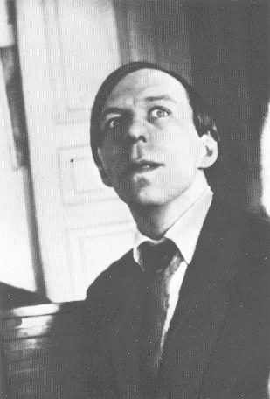

*Image sources:*  (1) http://www.primwriter.chat.ru/ase.html

(2) http://a-pesni.org/grvojna/poesia/aseev.php